**Assignment 2:** Produce a comparative infographic of TDD, BDD, and FDD methodologies. Illustrate their unique approaches, benefits, and suitability for different software development contexts. Use visuals to enhance understanding.

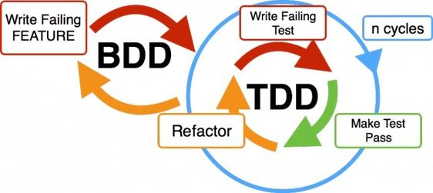

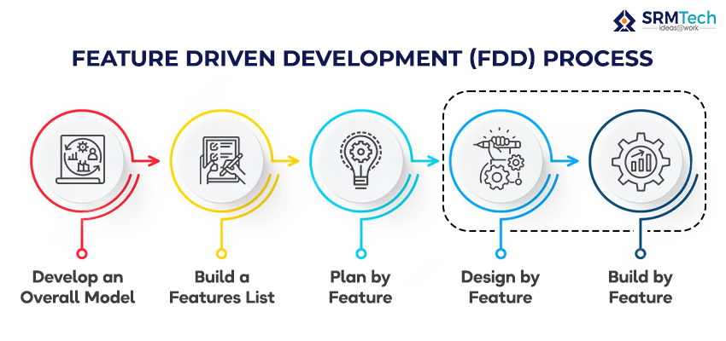

**TDD:**

* TDD is a test case driven approach where the test cases were written to the individual features in project requirement.
* Here we already know the cases where the code can fail so we write the code accordingly to pass the test cases.

Advantages of TDD:

* Faster debugging
* Modularity
* Less chances of errors

**BDD:**

* BDD is a behaviour driven development.
* It focuses on the communication and understanding of the project to all the teams in the project like business analyst, product analyst, developer, testing.
* It uses a common language gherkin.
* It focuses on whether the software is developed as per the client requirement or not.
* The main focus of the BDD is customer requirement satisfaction.

Advantages of BDD:

* Early defects detections.
* Team collaboration.
* Better requirement understanding.

**FDD:**

* FDD is a Features Driven Development.
* It is an iterative incremental software development methodology.
* In FDD, the software product is developed feature by feature in an incremental approach.
* Focuses on developing the working software with the feature that satisfy the client needs.

Advantages of FDD:

* All the required features taken as a list.
* Every feature will be assigned to a team.